**BANK LOAN REPORT ANALYSIS**

**SUMMARY REPORT**

1. **KPI’s**

**Total Loan Applications**

**SELECT count(id) AS Total_Loan_Applications FROM financial_loan;**



**MTD_Total Loan Applications**

**SELECT count(id) AS MTD_Total_Loan_Applications FROM financial_loan**

**WHERE MONTH(issue_date) = 12 AND YEAR(issue_date) = 2021;**



**MTD_Total Loan Applications**

**SELECT count(id) AS PMTD_Total_Loan_Applications FROM financial_loan**

**WHERE MONTH(issue_date) = 11 AND YEAR(issue_date) = 2021;**



**Total Funded Applications**

**SELECT SUM(loan_amount) AS Total_Funded_Amount FROM financial_loan;**



**MTD Total Funded Applications**

**SELECT SUM(loan_amount) AS MTD_Total_Funded_Amount FROM financial_loan**

**WHERE MONTH(issue_date) = 12 AND YEAR(issue_date) = 2021;**



**PMTD Total Funded Applications**

**SELECT SUM(loan_amount) AS PMTD_Total_Funded_Amount FROM financial_loan**

**WHERE MONTH(issue_date) = 11 AND YEAR(issue_date) = 2021;**



**Total Amount Received**

**SELECT SUM(total_payment) AS Total_Amount_received FROM financial_loan;**



**MTD Total Amount Received**

**SELECT SUM(total_payment) AS MTD_Total_Amount_received FROM financial_loan**

**WHERE MONTH(issue_date) = 12 AND YEAR(issue_date) = 2021;**



**PMTD Total Amount Received**

**SELECT SUM(total_payment) AS PMTD_Total_Amount_received FROM financial_loan**

**WHERE MONTH(issue_date) = 11 AND YEAR(issue_date) = 2021;**



**Average Interest Rate**

**SELECT ROUND(AVG(int_rate), 5) *100 AS Avg_Interest_Rate FROM financial_loan;**



**MTD Average Interest Rate**

**SELECT ROUND(AVG(int_rate), 5) *100 AS MTD_Avg_Interest_Rate FROM financial_loan**

**WHERE MONTH(issue_date) = 12 AND YEAR(issue_date) = 2021;**



**PMTD Average Interest Rate**

**SELECT ROUND(AVG(int_rate), 5)*100 AS PMTD_Avg_Interest_Rate FROM financial_loan**

**WHERE MONTH(issue_date) = 11 AND YEAR(issue_date) = 2021;**



**Average DTI (Debt-to-Income)**

**SELECT ROUND(AVG(dti),5) * 100 AS Avg_DTI FROM financial_loan;**



**MTD Average DTI**

**SELECT ROUND(AVG(dti),5) * 100 AS MTD_Avg_DTI FROM financial_loan**

**WHERE MONTH(issue_date) = 12 AND YEAR(issue_date) = 2021;**



**PMTD Average DTI**

**SELECT ROUND(AVG(dti),5) * 100 AS PMTD_Avg_DTI FROM financial_loan**

**WHERE MONTH(issue_date) = 11 AND YEAR(issue_date) = 2021;**



**GOOD LOAN ISSUED**

**Good Loan Percentage**

**SELECT**

**ROUND((COUNT(CASE WHEN loan_status = 'Fully Paid' OR loan_status = 'Current' THEN id END) *100)**

**/**

**COUNT(id),**

**2) AS Good_loan_percentage**

**FROM financial_loan;**



**Good Loan Applications**

**SELECT COUNT(id) AS Good_Loan_Applications FROM financial_loan**

**WHERE loan_status = 'Fully Paid' OR loan_status = 'Current';**



**Good Loan Funded Amount**

**SELECT SUM(loan_amount) AS Good_Loan_Funded_Amount FROM financial_loan**

**WHERE loan_status = 'Fully Paid' OR loan_status = 'Current';**



**Good Loan Amount Received**

**SELECT SUM(total_payment) AS Good_Loan_Amount_Received FROM financial_loan**

**WHERE loan_status = 'Fully Paid' OR loan_status = 'Current';**



**BAD LOAN ISSUED**

**Bad Loan Percentage**

**SELECT**

**ROUND((COUNT(CASE WHEN loan_status = 'Charged Off' THEN id END) *100.0)**

**/**

**COUNT(id),**

**2) AS Bad_loan_percentage**

**FROM financial_loan;**



**Bad Loan Applications**

**SELECT COUNT(id) AS Bad_Loan_Applications FROM financial_loan**

**WHERE loan_status = 'Charged Off';**



**Bad Loan Funded Amount**

**SELECT SUM(loan_amount) AS Bad_Loan_Funded_amount FROM financial_loan**

**WHERE loan_status = 'Charged Off';**



**Bad Loan Amount Received**

**SELECT SUM(total_payment) AS Bad_Loan_Amount_Received FROM financial_loan**

**WHERE loan_status = 'Charged Off';**



**LOAN STATUS**

**SELECT**

**loan_status,**

**COUNT(id) AS Total_Loan_applications,**

**SUM(total_payment) AS Total_Amount_Received,**

**SUM(loan_amount) AS Total_Funded_Amount,**

**AVG(int_rate * 100) AS Interest_Rate,**

**AVG(dti * 100) AS DTI**

**FROM**

**financial_loan**

**GROUP BY**

**loan_status;**



**Loan Status MTD**

**SELECT**

**loan_status,**

**SUM(total_payment) AS MTD_Total_Amount_Received,**

**SUM(loan_amount) AS MTD_Total_Funded_Amount**

**FROM financial_loan**

**WHERE MONTH(issue_date) = 12**

**GROUP BY loan_status;**

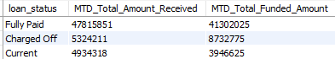

**OVERVIEW DASHBOAD [BANK REPORT ANALYSIS]**

**MONTH**

**SELECT**

**MONTH(issue_date) AS Month_Number,**

**MONTHNAME(issue_date) AS Month_Name,**

**COUNT(id) AS Total_Loan_Applications,**

**SUM(loan_amount) AS Total_Funded_Amount,**

**SUM(total_payment) AS Total_Received_Amount**

**FROM financial_loan**

**GROUP BY Month_Number,Month_Name**

**ORDER BY Month_Number;**

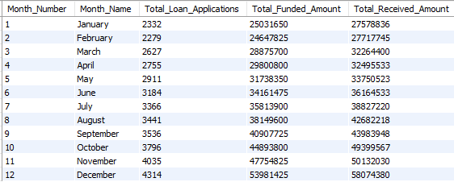

**REGIONAL/STATE ANALYSIS**

**SELECT**

**address_state,**

**COUNT(id) AS Total_Loan_Applications,**

**SUM(loan_amount) AS Total_Funded_Amount,**

**SUM(total_payment) AS Total_Received_Amount**

**FROM financial_loan**

**GROUP BY address_state**

**ORDER BY Total_Funded_Amount DESC;**

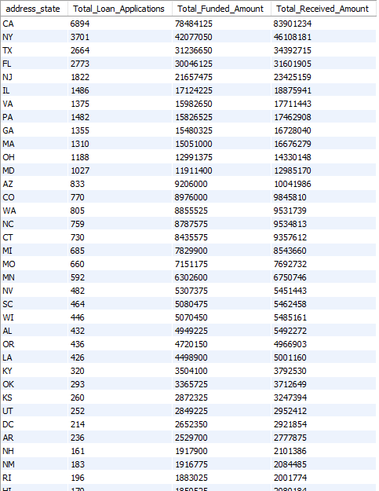

**Loan Term**

**SELECT**

**term,**

**COUNT(id) AS Total_Loan_Applications,**

**SUM(loan_amount) AS Total_Funded_Amount,**

**SUM(total_payment) AS Total_Received_Amount**

**FROM financial_loan**

**GROUP BY term**

**ORDER BY term;**



**Employee Length**

**SELECT**

**emp_length,**

**COUNT(id) AS Total_Loan_Applications,**

**SUM(loan_amount) AS Total_Funded_Amount,**

**SUM(total_payment) AS Total_Received_Amount**

**FROM financial_loan**

**GROUP BY emp_length**

**ORDER BY Total_Loan_Applications DESC;**

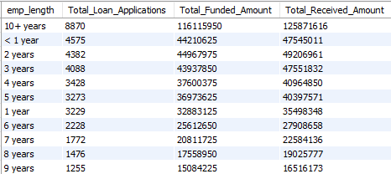

**Loan Purpose Breakdown**

**SELECT**

**purpose,**

**COUNT(id) AS Total_Loan_Applications,**

**SUM(loan_amount) AS Total_Funded_Amount,**

**SUM(total_payment) AS Total_Received_Amount**

**FROM financial_loan**

**GROUP BY purpose**

**ORDER BY Total_Loan_Applications DESC;**

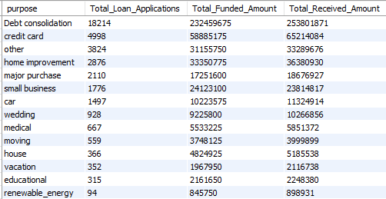

**Home Ownership Analysis**

**SELECT**

**home_ownership,**

**COUNT(id) AS Total_Loan_Applications,**

**SUM(loan_amount) AS Total_Funded_Amount,**

**SUM(total_payment) AS Total_Received_Amount**

**FROM financial_loan**

**GROUP BY home_ownership**

**ORDER BY Total_Loan_Applications;**

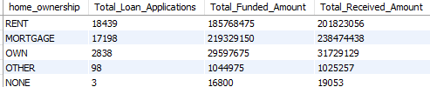

**Note: All dashboards have multiple filters applied. You can test the impact of these filters by adjusting the query and observing the results.**

**For example, select Grade A from the filters to see how the dashboard data changes accordingly.**

**SELECT**

**home_ownership,**

**COUNT(id) AS Total_Loan_Applications,**

**SUM(loan_amount) AS Total_Funded_Amount,**

**SUM(total_payment) AS Total_Received_Amount**

**FROM financial_loan**

**WHERE grade = 'A' AND address_state = 'CA'**

**GROUP BY home_ownership**

**ORDER BY Total_Loan_Applications DESC;**

